School of Health and Social Work

Doctorate in
Clinical Psychology

Ethics and
Research Governance Guide

Version 1.3 22.2.2018

Table of Contents
1 Introduction 3
2 BPS Research ethics principles and standards 3
3 NHS research principles 5
4 Does my study need ethical approval? Discriminating between Research, Clinical Audit or Service Evaluation. 7
5 Obtaining Ethical and Organisational Approval 9
5.1 NHS based studies 9
5.2 Non-NHS based studies 10
5.3 Preparing your IRAS application and documentation 15
5.3.1 Contact Trust sponsor and R&D departments 15
5.3.2 The IRAS application 15
5.3.3 Consent forms and Information Sheets 16
5.3.4 Statement of Activities and Schedule of Events forms 16
5.4 Booking your application for review 18
5.5 Proportionate review 18
5.6 How will my proposal be assessed by the NHS Ethics committee? 20
5.7 Attending the meeting 21
5.8 Obtaining HRA and trust approval following ethical review 22
6 Actions required after approval has been granted 23
6.1 Substantial amendments 23
6.1 Annual Progress Report Form and Declaration of the End of a Study 24
7 Applying for Ethics approval for non-NHS studies or for NHS staff projects 24
8 Useful sources of information 26
9 Glossary 27

Introduction

As a clinical psychologist you need to understand research ethics and be able to apply them. the UK policy framework for health and social care research (Department of Health, 2017) outlines the standards that are required for all research carried out within the National Health Service (NHS). The framework applies to all types of research including that carried out by students or trainees and outlines key research principles (see section 3). The British Psychological Society(BPS) also set out research ethics principles that all psychologists should adhere to (section 3).
The aim of this guide is to explain the concept of ethics in research and outline the processes that should be followed to fulfil the requirements of ethical and research and development approval. Where research does not involve NHS patients, resources or premises the levels of stringency outlined in the NHS research standards also apply but there are separate arrangements for obtaining ethical approval via the Faculty of Health Sciences Research Ethics Committee (see section 7).
You must also be aware of and follow the University of Hull’s Code of Good Research Practice, Code of Ethics and the University Procedures for Granting Ethical Approval before an application to Faculty of Health Science Research Ethics Committee.

BPS Research ethics principles and standards

The BPS in their Code of Human Research Ethics set out key principles and standards relating to research ethics which trainees should be familiar with and adhere to:
Respect for the autonomy, privacy and dignity of individuals and communities
Ethics standards: Psychologists have respect for the autonomy and dignity of persons. In the research context this means that there is a clear duty to participants. For example, psychologists respect the knowledge, insight, experience and expertise of participants and potential participants. They respect individual, cultural and role differences, including those involving age, disability, gender reassignment, marriage and civil partnership, pregnancy and maternity, race (including colour, nationality, ethnic or national origin), religion and belief, sex, sexual orientation, education, language and socio-economic status. Given this level of respect psychologists are naturally willing to explain the nature of the research to which participants are being asked to contribute, and to avoid any unfair, prejudiced or discriminatory practice, for example, in participant selection or in the content of the research itself.
For these reasons they accept that individuals may choose not to be involved in research, or if they agree to participate they may subsequently request that their data be destroyed. Under such circumstances researchers will comply with any requests that any related data be destroyed, and removed from any datasets. Where there are necessary time limits on data withdrawal, for example up to a point at which data are aggregated, these limits should always be made clear to participants. Psychologists respect the autonomy of individuals by making reasoned judgments about any actions in the course of their research that will have an impact on the autonomy of participants, even temporarily, and will always avoid any processes and procedures where any long-term impairment or perceived impairment of autonomy might result. A reasoned balance should be struck between protecting participants and recognising their agency and capacity. Researchers will respect the privacy of individuals, and will ensure that individuals are not personally identifiable, except in exceptional circumstances and then only with clear, unambiguous informed consent. They will respect confidentiality, and will ensure that information or data collected about individuals are appropriately anonymised and cannot be traced back to them by other parties, even if the participants themselves are not troubled by a potential loss of confidentiality. Where a participant wishes to have their voice heard and their identity linked with this, researchers will endeavour to respect such a wish. In their research, as in all other professional dealings, psychologists will seek to ensure that people’s rights are respected and protected.
Scientific integrity
Ethics standards: Psychologists are committed to ensuring that the scientific and scholarly standards of their research are accountable and of sufficiently high quality and robustness. Quality relates primarily to the scientific design of the research and the consideration of potential risks of harm and protocols for addressing such difficulties (should they arise). It is important that the aims of the research are as transparent as possible to ensure that it is clear what the research intends to achieve. Judgements of scientific value must be appropriate within the context in which the research is being conducted (e.g. the status of the researcher – student, lecturer, senior researcher).
Social responsibility
Ethics standards: The aim of generating psychological knowledge should be to support beneficial outcomes. Such outcomes can be broadly defined as those that not only support and reflect respect for the dignity and integrity of persons (both individually and collectively) but also contribute to the ‘common good’. Accordingly, psychologists must be able to work in partnership with others (including professional colleagues, research participants, and other persons); be self-reflective; and be open to challenges that question the contributions of psychological knowledge to society. Psychology researchers need to be aware of their personal and professional responsibilities, to be alert to the possible consequences of unexpected as well as predicted outcomes of their work, and to acknowledge the often problematic nature of the interpretation of research findings. They should always work within the limits of their professional competence.
Maximising benefit and minimising harm
Ethics standards: Psychology researchers should seek to maximise the benefits of their work at all stages, from inception through to dissemination. Harm to research participants must be avoided. Where risks arise as an unavoidable and integral element of the research, robust risk assessment and management protocols should be developed and complied with. Normally, the risk of harm should be no greater than that encountered in ordinary life, i.e. people should not be exposed to risks greater than or additional to those to which they are exposed in their normal lifestyles. Where a tension arises between the legitimate needs of research and the avoidance of risk, reasoned judgement should be applied, based on the principles in this Code of Human Research Ethics. If unavoidable additional risks are present, researchers should assess these risks for their probability and severity, and put in place measures to obviate, minimise and manage such risks. Psychologists need to be sensitive to the potential impact of their interventions, for example, to the possibility of individual distress that may be caused unwittingly, to the danger of ‘normalising’ unhelpful behaviours or to creating self-doubt. A difference in power inevitably exists between researchers and participants, even if researchers seek to minimise it. Sensitivity is, therefore, essential, and caution is usually necessary. In conjunction with the previous section of this Code of Human Research Ethics it may be that researchers will need to consider the costs to the individual participant versus potential societal benefits. This is a difficult balance to strike and should be arrived at by careful and explicit analysis, and where appropriate, wider consultation with experienced colleagues, the relevant REC or user group(s). Further discussion of risk in psychological research can be found in the following section.

NHS research principles

The UK policy framework for health and social care research (Department of Health, 2017) sets out Principles that apply to all health and social care research. The following statement of principles serves as a benchmark for good practice that the management and conduct of all health and social care research in the UK are expected to meet. Trainees are expected to be familiar with and adhere to these principles in their research.
Principle 1: Safety: The safety and well-being of the individual prevail over the interests of science and society.
Principle 2: Competence: All the people involved in managing and conducting a research project are qualified by education, training and experience, or otherwise competent under the supervision of a suitably qualified person, to perform their tasks.
Principle 3: Scientific and Ethical Conduct: Research projects are scientifically sound and guided by ethical principles in all their aspects.
Principle 4: Patient, Service User and Public Involvement: Patients, service users and the public are involved in the design, management, conduct and dissemination of research, unless otherwise justified.
Principle 5: Integrity, Quality and Transparency: Research is designed, reviewed, managed and undertaken in a way that ensures integrity, quality and transparency.
Principle 6: Protocol: The design and procedure of the research are clearly described and justified in a research proposal or protocol, where applicable conforming to a standard template and/or specified contents.
Principle 7: Legality: The researchers and sponsor familiarise themselves with relevant legislation and guidance in respect of managing and conducting the research. www.hra.nhs.uk/planning-and-improving-research/learning.
Principle 8: Benefits and Risks: Before the research project is started, any anticipated benefit for the individual participant and other present and future recipients of the health or social care in question is weighed against the foreseeable risks and inconveniences once they have been mitigated .
Principle 9: Approval: A research project is started only if a research ethics committee and any other relevant approval body have favourably reviewed the research proposal or protocol and related information, where their review is expected or required.
Principle 10: Information about the Research: In order to avoid waste, information about research projects (other than those for educational purposes) is made publicly available before they start (unless a deferral is agreed by or on behalf of the research ethics committee).
Principle 11: Accessible Findings: Other than research for educational purposes and early phase trials, the findings, whether positive or negative, are made accessible, with adequate consent and privacy safeguards, in a timely manner after they have finished, in compliance with any applicable regulatory standards, i.e. legal requirements or expectations of regulators. In addition, where appropriate , information about the findings of the research is available, in a suitable format and timely manner, to those who took part in it, unless otherwise justified.
Principle 12: Choice: Research participants are afforded respect and autonomy, taking account of their capacity to understand. Where there is a difference between the research and the standard practice that they might otherwise experience, research participants are given information to understand the distinction and make a choice, unless a research ethics committee agrees otherwise. Where participants’ explicit consent is sought, it is voluntary and informed. Where consent is refused or withdrawn, this is done without reprisal.
Principle 13: Insurance and Indemnity: Adequate provision is made for insurance or indemnity to cover liabilities which may arise in relation to the design, management and conduct of the research project.
Principle 14: Respect for Privacy: All information collected for or as part of the research project is recorded, handled and stored appropriately and in such a way and for such time that it can be accurately reported, interpreted and verified, while the confidentiality of individual research participants remains appropriately protected. Data and tissue collections are managed in a transparent way that demonstrates commitment to their appropriate use for research and appropriate protection of privacy.
Principle 15: Compliance Sanctions: for non-compliance with these principles may include appropriate and proportionate administrative, contractual or legal measures by funders, employers, relevant professional and statutory regulators, and other bodies.

Does my study need ethical approval? Discriminating between Research, Clinical Audit or Service Evaluation.

One of the first considerations before commencing a study is to determine whether ethical approval is required. Table 1 outlines the key differences between Research, Service Evaluation and Clinical Audit. Any project that falls within the definition of Research must be approved by the Health Research Authority. This in most cases also include by an NHS appointed Research Ethics Committee (REC) and be approved by the trust where the research is undertaken (known as R&D approval or Trust approval). The exception to this is NHS staff projects A sponsor is also required which for doctorate course trainees is the Humber Foundation Trust. The sponsor:
- is responsible for ensuring expert scientific and ethics reviews are carried out;
- ensures arrangements are in place to be alerted to significant developments;
- ensures arrangements are in place for compensation.
The major project you undertake as part of your training will be classed as Research which needs Health Research Authority approval where as the aim of your project is to derive generalizable new knowledge.
The Small Scale Project that you complete during your first year will not require REC and R&D approval providing it falls within the classifications of Service Evaluation or Clinical Audit. It is recommended that when selecting a small scale project you choose an area that does not require REC and R&D approval (see the Small Scale Project guide on Canvas for more information).
Note that although some projects may not require ethical approval, organisational and research governance approval may still be required. The relevant R&D department of the trust in which the project is undertaken should be consulted prior to the commencement of the project to check which approvals are required.
Table 1. How to discriminate between Research, Service Evaluation and Clinical Audit.(from Defining Research leaflet, http://www.nres.npsa.nhs.uk/home/, 2009)

RESEARCH | SERVICE EVALUATION | CLINICAL AUDIT
The attempt to derive generalizable new knowledge  including studies that aim to generate hypotheses as  well as studies that aim to test them. | Designed and conducted  solely to define or judge  current care. | Designed and conducted  to produce information to  inform delivery of best  care
Quantitative research – designed to test a hypothesis.  Qualitative research – identifies/explores themes  following established methodology. | Designed to answer:  “What standard does this  service achieve?” | Designed to answer:  “Does this service reach a  predetermined  standard?”
Addresses clearly defined questions, aims and  objectives. | Measures current service  without reference to a  standard. | Measures against a  standard.
Quantitative research – may involve evaluating or  comparing interventions, particularly new ones.  Qualitative research – usually involves studying how  interventions and relationships are experienced. | Involves an intervention  in use only. The choice of  treatment is that of the  clinician and patient  according to guidance,  professional standards  and/or patient preference. | Involves an intervention  in use only. The choice of  treatment is that of the  clinician and patient  according to guidance,  professional standards  and/or patient preference.
Usually involves collecting data that are additional to  those for routine care but may include data collected  routinely. May involve treatments, samples or  investigations additional to routine care. | Usually involves analysis  of existing data but may  include administration of  interview or  questionnaire. | Usually involves analysis  of existing data but may  include administration of  simple interview or  questionnaire.
Quantitative research – study design may involve  allocating patients to intervention groups.  Qualitative research – uses a clearly defined sampling  framework underpinned by conceptual or theoretical  justifications.  L PRACTICE | No allocation to  intervention: the health  professional and patient  have chosen intervention  before service evaluation | No allocation to  intervention: the health  professional and patient  have chosen intervention  before audit.
May involve randomisation | No randomisation | No randomisation
Normally requires REC review | Does not require  REC review | Does not require  REC review

Obtaining Ethical and Organisational Approval

There are various routes to obtaining ethical and organisational approval depending on how applicants are recruited. The table and flow chart at the end of this section provide a summary of the steps required. It is essential that contact is made with organisations as soon as possible in the research process to check which approvals are required and that they are willing to help facilitate the study. Applications to the NHS can be complex and time consuming so getting started early is essential.

NHS based studies
Approval Routes 1a) and 1b) apply to any research involving any element of NHS patients, staff, resources or premises and before commencement requires:
- Health Research Authority (HRA) approval. Applications are made via the Integrated Research Application System (IRAS).
- HRA approval includes Ethical approval from an NHS appointed Research Ethics Committee (REC). The exception to this is for NHS staff projects where HRA approval is required but ethical approval is obtained via the Faculty of Health Sciences ethics committee prior to the application to the HRA. To avoid duplication NHS staff project applications can be made to the Faculty committee using the HRA IRAS application form.
- NHS Research and Development approval of each trust where the research is to take place (also known as Trust approval). Individual trusts need to confirm the Capacity and Capability for the research to go ahead following HRA approval.
If a study involves a mix of NHS and non-NHS participants the above approvals are required (Route 2). For the non-NHS organisations individual approval will also be required.
The approval process for the HRA involves and integrated assessment by the HRA and ethics approval process. Figure 1 sets out the process from initial application to approval.
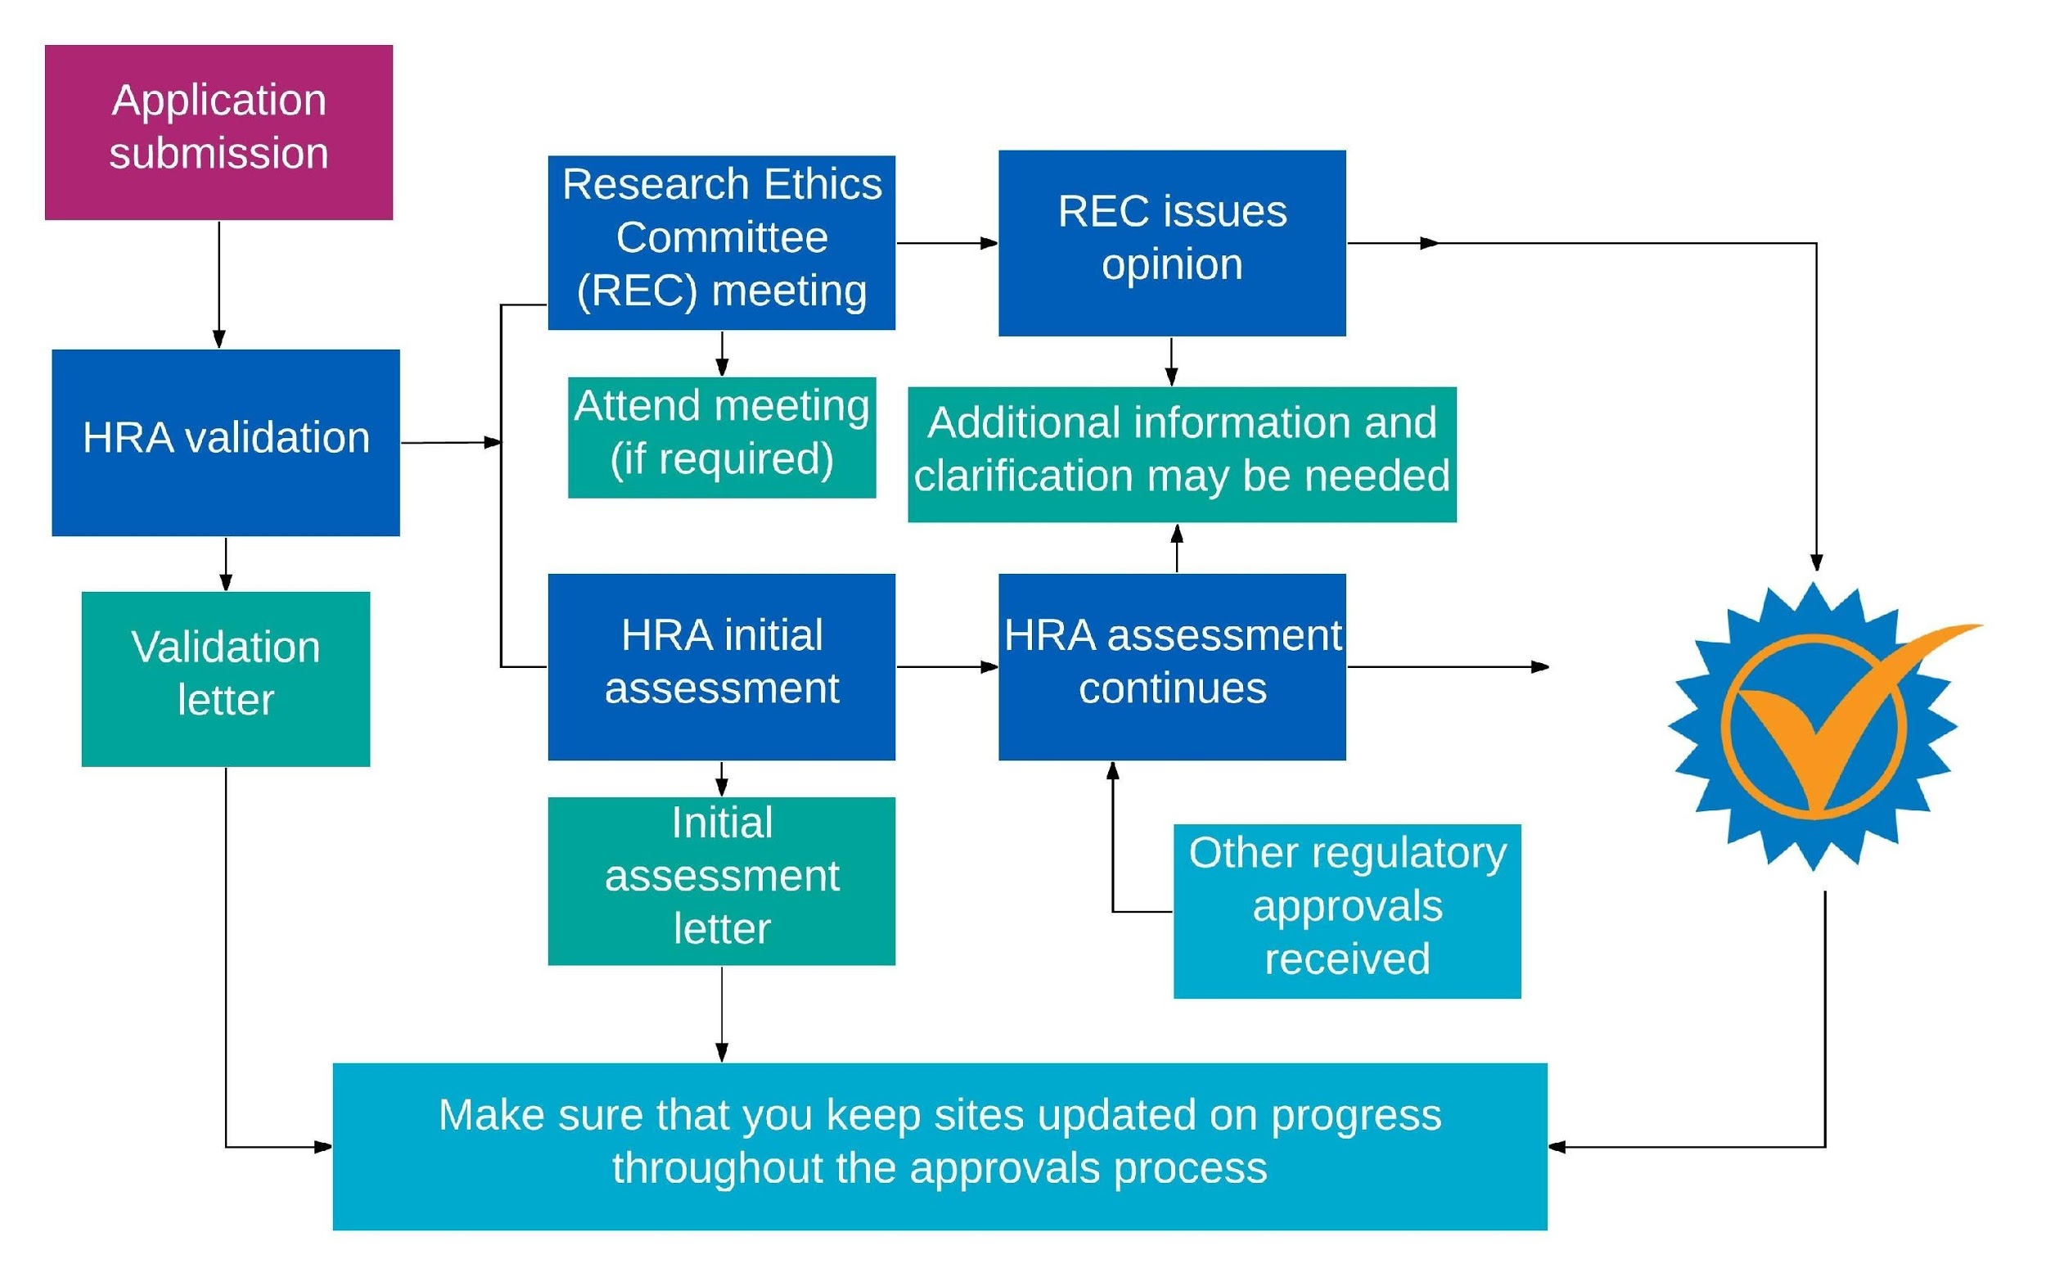
Figure 1 Health Research Authority Approval process (retrieved from https://www.hra.nhs.uk/approvals-amendments/what-approvals-do-i-need/hra-approval/ )

Non-NHS based studies
For research where there is no element of NHS recruitment the following approvals are required (Route 3):
- Faculty of Health Sciences ethics committee approval
- Approval of the organisations through which recruitment will take place. In some cases this may require additional applications to individual organisations. This should be checked on initial contact with each organisation.
Applications are made electronically via email using the relevant application form. Guidance for applicants and forms are available at Canvas/Clinical Community/Research Guidelines/Ethics and R&D/University ethics
See Section 7 for further information.

Route 1 a) and b) –HRA approval  Recruiting via NHS –  NHS patients 1a) or NHS staff 1 b)  e.g. Humber, HEY , TEWV NHS trusts. | Route 2- HRA approval  Recruiting via NHS –  NHS patients  Plus other non-NHS organisations  e.g. Humber, HEY , TEWV NHS trusts, plus university students plus voluntary organisations etc | Route 3  Non-NHS organisations only  e.g.  University students,  Social services  Schools  Voluntary organisations  General public  Internet
1a) IRAS Form HRA approval including NHS ethics for patient based studies plus  OR  1b) Use IRAS Form - for University ethics for NHS staff studies plus HRA approval  Plus a) and b) both need individual trust R&D approval | IRAS Form HRA approval including NHS ethics approval for NHS patients plus.  Plus individual trust R&D approval  Plus any non-NHS organisation approval | University ethics (Form A1)  Plus any individual organisation approval
http://www.hra.nhs.uk/resources/  Ethics Application – electronically via IRAS - register at  https://www.myresearchproject.org.uk/  R&D contacts  http://www.rdforum.nhs.uk/content/contact-details/ |  | Sharepoint/FHS/Ethics  Canvas/Clinical Community/Research Guidelines/Ethics and R&D/University ethics Application by email

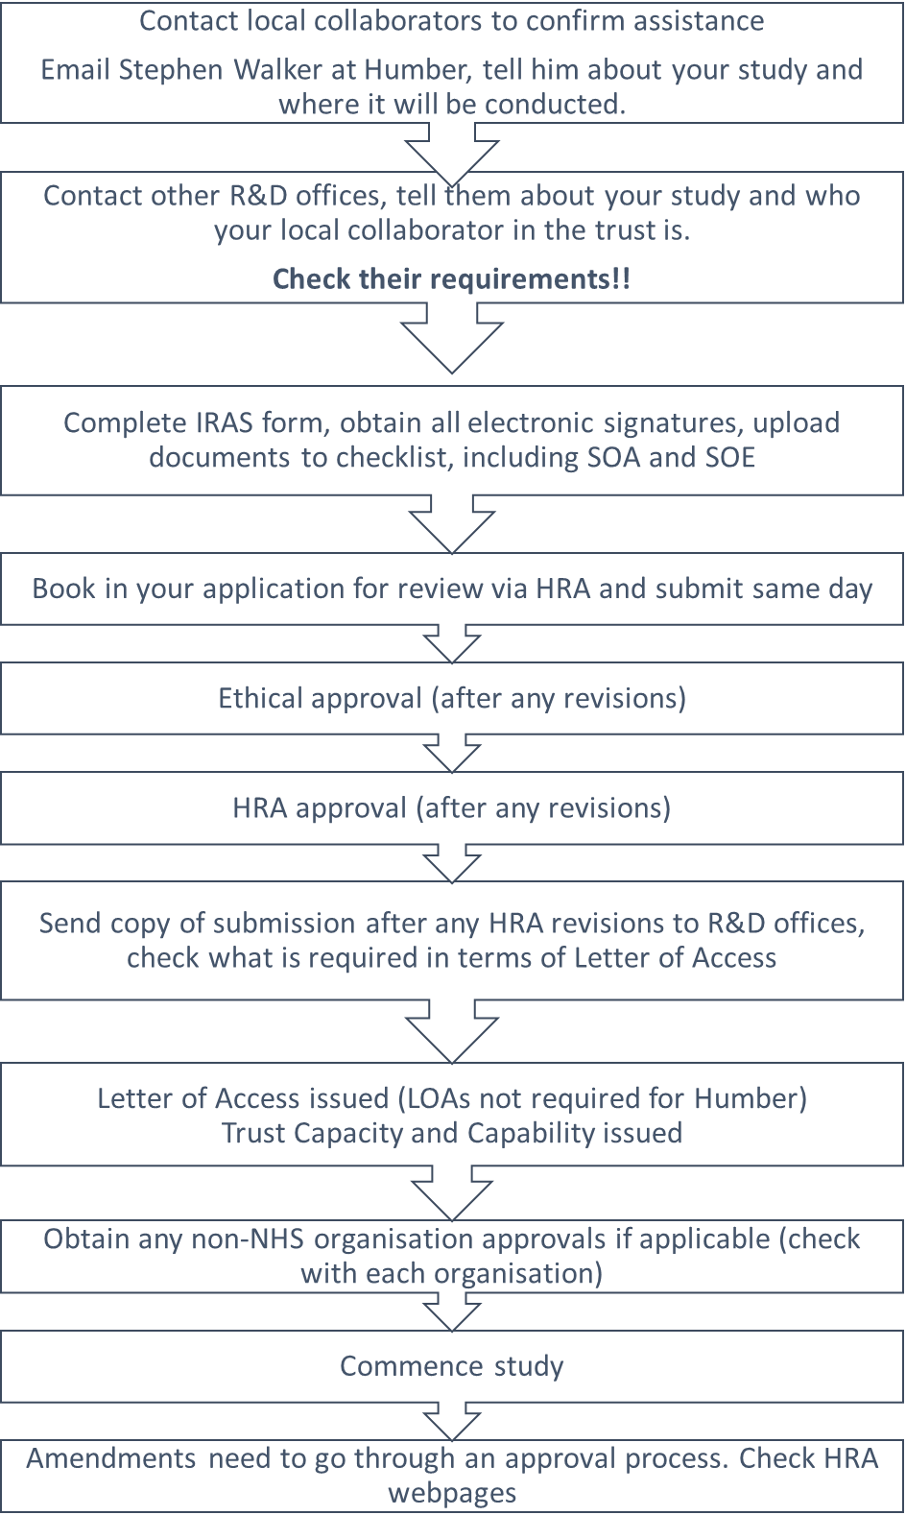

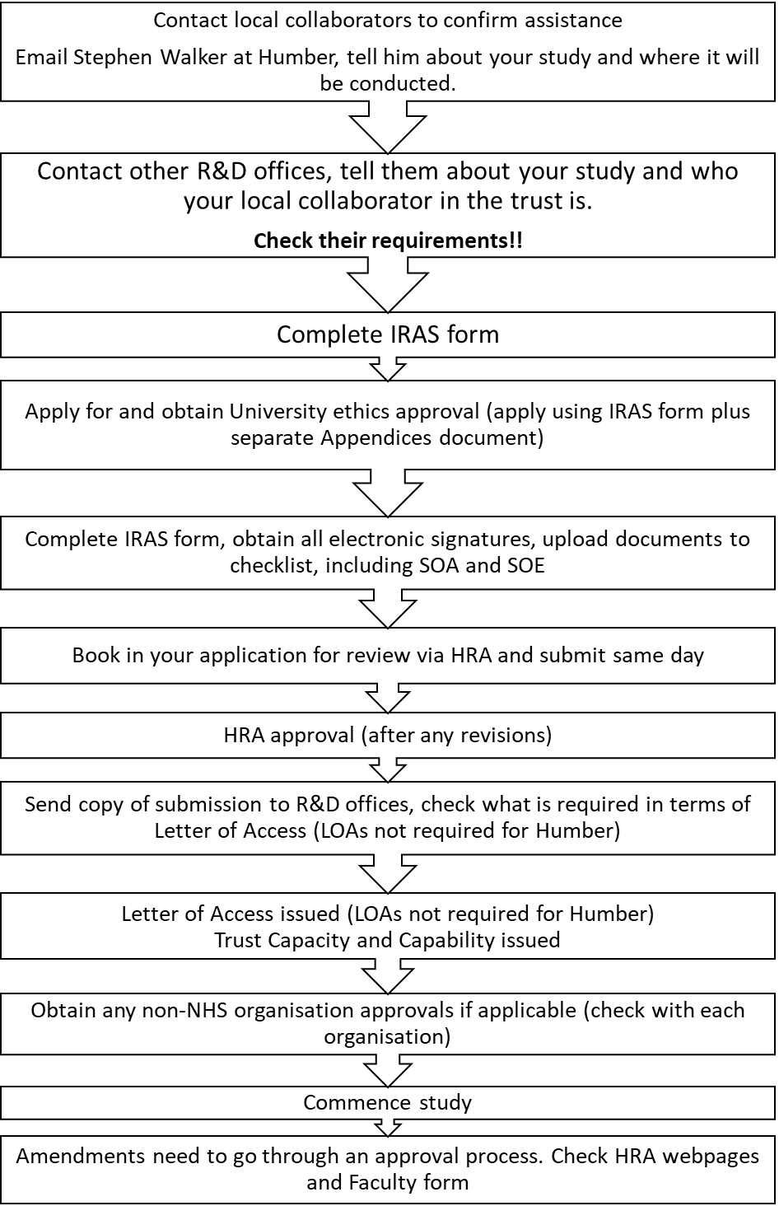

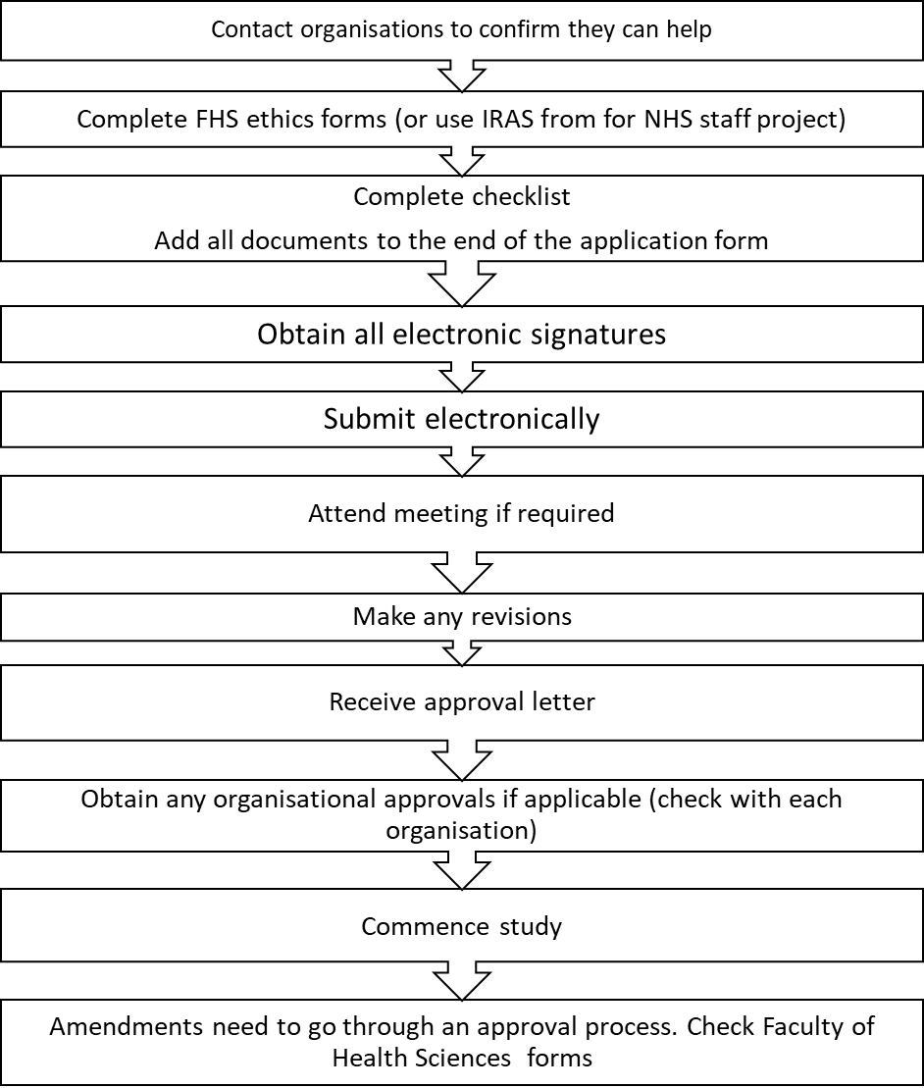

Preparing your IRAS application and documentation

Contact Trust sponsor and R&D departments
Before you start your IRAS application you should contact the sponsor of your study. As you are employed by the NHS this is Stephen Walker and Humber NHS Foundation Trust. HNF-TR.ResearchTeam@nhs.net It is important that you advise him of the tile of the study and where it will take place. If it involves other NHS trusts he will request on your behalf a copy of your employment pre-engagement checks as these will be required by other trusts before they provided a Letter of Access for you to undertake your research.
You should also contact other trusts to inform them of you study and ask what information they need. Some trusts have different requirements so it is important for you to be aware of this at the outset.
Trusts will ask who you are collaborating in each trust with in terms of help with recruitment etc. They may also require evidence that they are happy for the study to proceed. Early contact with such contacts is vital.

Contact details for R&D departments can be found at http://www.rdforum.nhs.uk/content/contact-details/

The IRAS application
The Integrated Research Application System (IRAS) is an on-line system that you will use to apply for ethical approval.
IRAS can be accessed via https://www.myresearchproject.org.uk/ . You will have to register your details on IRAS before commencing your application. Following registration you will create a new project on the system and be asked a series of Project filter questions which will determine the information that is required for your application. There are many help facilities on IRAS to help you with this process. The user manual is in pdf format and gives in depth information on the system : https://www.myresearchproject.org.uk/Help/Contents/IRASHelp_UserManual.pdf
There is also an on-line training module which gives an overview and useful introduction to how the application system works: https://www.myresearchproject.org.uk/ELearning/IRAS_E_learning.htm
Most questions on the application form also have guidance notes attached.
Once you have created your account and set up your project you can begin to complete the IRAS application form. Work can be saved so you can complete the application in stages and return to it at a later date.
Included with the REC form on IRAS is a checklist of what you should include with your application. All supporting documents should be uploaded to the checklist. You should include version numbers for documents where applicable as the REC co-ordinator will reject the application if these are not completed. The IRAS Project ID number for the application should be included on information sheet and consent forms Not every item will be relevant to your study and items such as letter from funder and statistician do not need to be included. You should include your peer review document i.e. feedback from your final research proposal and CVs of yourself and academic supervisor. A CV template is available in the My account section of IRAS. The peer review document of your final research proposal should be uploaded together with your final corrected research proposal. It may be useful to include a document showing how you have dealt with the recommendations from peer review as in some cases you may not have implemented all of the recommendations following discussion with your supervisor.
When your IRAS form is complete and all documents uploaded to the checklist you will need to obtain the electronic signature of yourself, your supervisor and the study sponsor (Stephen Walker at Humber NHS Foundation Trust). This is done via the Authorisations tab on the IRAS form.
An example IRAS form is available via logon details provided by the Research co-Ordinator.

Consent forms and Information Sheets
Informed consent and Information Sheets are key documents that the ethics committee will review as part of your application. Informed consent is a cornerstone of research ethics and it is crucial that before taking part in your study, participants know exactly what is involved and the potential risks and benefits of taking part. They also need to know how the data you collect will be handled and how confidentiality will be protected. Another key consideration is the type of language you use when inviting someone to take part. There should be no hint of coercion and you should always ‘invite’ someone to take part rather than ‘wanting’ them to take part. Participants should feel under no compulsion, pressure or duty to take part, the decision must be entirely theirs based on the information you provide them.
The information you give participants and the terms under which you are asking to consent will be scrutinised closely by the committee. The HRA provide guidance regarding this: http://www.hra-decisiontools.org.uk/consent/

Statement of Activities and Schedule of Events forms

These forms should be completed and uploaded to the IRAS form checklist. They set out the activities and events that will take place in the NHS research site and enable trusts to assess capacity and capability for the research to proceed. Guidance and templates are available on the HRA web pages https://www.hra.nhs.uk/planning-and-improving-research/research-planning/prepare-study-documentation/ Stephen Walker at Humber NHS Foundation Trust can give guidance on the completion of these also.

Booking your application for review
When all documentation has been completed and the IRAS electronically signed you are in a position to arrange for your application to be reviewed by the HRA. Submission guidance is provided within the Submission tab on the IRAS form. This involves a phone call to the HRA to the Central Booking Service.
Booking and submission must be completed on the same day so the IRAS form must be complete and ready to submit, do not proceed until everything is ready.

Proportionate review
For studies where there are no material ethical issues NHS ethics committee Proportionate review (PR) is designed as a fast track method of gaining ethical opinion and following acceptance of a valid application a reply is given in 21 days by a sub-committee. The applicant does not attend a meeting and queries are usually dealt with over the phone. Applications are made in the same way to the HRA as for full ethical review via IRAS. The Central Booking Service operators ask a number of questions to establish if an application should be booked to a Full or Proportionate Review meeting. Upon receipt the Research Ethics Committee Manager undertakes a thorough pre- screen of the application to gauge its PR suitability.
The Proportionate Review sub-committee also give consideration to the applications suitability for PR when the application is sent for review.
The HRA publish guidance which outlines which studies are suitable for this method of review. https://www.hra.nhs.uk/approvals-amendments/what-approvals-do-i-need/research-ethics-committee-review/applying-research-ethics-committee/ A study may be is eligible if it is:
Questionnaire research that does NOT include highly sensitive areas or where accidental disclosure would NOT have serious consequence (sensitive questionnaires which are validated for use in the proposed population and used by experienced practitioners are acceptable for PR) 5.
Research interview / focus group that does not include highly sensitive areas or where accidental disclosure would NOT have serious consequence
Other factors that may be considered in determining eligibility included:
- The research procedures when considered together are overly arduous and/or burdensome.
- The vulnerability of the participant group at the time of approach to participate
- The overall sensitivity of the application and topics being covered combined with the potential for participant distress

What constitutes a highly sensitive area can be open to different interpretations.

How will my proposal be assessed by the NHS Ethics committee?
Upon acceptance for review at an NHS ethics committee your application will be assigned to a lead reviewer and a second reviewer on the committee (or to a sub-committee of members for proportionate review). Reviewers will take an in depth look at your proposal to decide whether it meets the ethical standards required. The proposal is also circulated to all other members of the committee for comments. In addition to protecting the dignity, rights, safety and wellbeing of participants they will also look at the feasibility and scientific justification for the study. Committees generally have a set list of aspects that they will consider for each proposal. Table 2 sets out the broad areas that will be considered in the review.
It is a good idea to check through your proposal and application to make sure it adequately covers all of the areas that will be reviewed.

Table 2. Issues typically reviewed by Ethics committees
1. The suitability of the applicant and supporting staff

2. The quality of the facilities

3. The relevance of the research and research design

4. Evaluation of anticipated benefits and risks for individual trial subject and other present and future patients
5. The care and protection of the research subject

6. Hazards, discomfort and distress of subjects

7. Consent of the research subject, including justification for research on persons incapable of giving consent (where appropriate)

8. The adequacy and completeness of written information to be given and procedure followed when obtaining informed consent

9. Recruitment arrangements

10. Confidentiality, including the rights of the subject to physical and mental integrity, to privacy and to the protection of data

11 The provision of Indemnity and compensation

12 General comments on the application

Attending the meeting
Each Research Ethics Committee (REC) consists of between seven and 15 members. Each Committee has a Chair who directs proceedings and a co-ordinator who organises the meeting and all associated paperwork.
At least one-third of the members must be ‘lay’. Lay members are people whose main personal or professional interest is not in a research area. The remainder of the Committee are expert members, who are specialists including doctors, other healthcare professionals and academics. REC members are given special ethics training and give their time freely other than expenses.
The course strongly recommends that you and your supervisor attend the Ethics committee meeting if possible and you will be invited to do so by the Committee. The purpose of this is to be available to respond directly to requests from the Committee for further information, clarification or reassurance. In this way, many issues of concern to the Committee may be resolved at the meeting. Committees welcome your attendance for this reason as it makes it easier for them to come to a decision regarding your application. This can save time in the long run as any queries can be addressed face to face at the meeting. Your research supervisor is also encouraged to attend if possible.
At the meeting the lead and second reviewer will present their opinion of the application to the rest of the Committee who will also have the opportunity to make comments. Following this discussion you will be invited into the meeting room and usually be asked to give a very brief summary of your study. You may also be asked to outline what the key ethical issues are and how you intend to address them. For example there may be a risk that your study might cause distress to some individuals so you would have to be explicit in how you would handle such a situation. This should have already been covered in your proposal.
Once you have answered the Committee’s questions you will be asked to leave the meeting. The Committee will then reach a decision regarding the application which will be conveyed to you in writing at a later date. The committee will reach one of the following decisions:
(i) Final opinion. This opinion may be either:

- favourable
- unfavourable

(ii) Provisional opinion with request for further information. The Committee may decide that an opinion cannot be issued until further information or clarification has been received from the applicant.
(iii) No opinion. The Committee may decide that no opinion can be given until a referee has been consulted.
In the event of an unfavourable opinion the application can be resubmitted at a later date to the same committee or to another committee if is felt that the issues raised regarding the first proposal can be adequately addressed.

Obtaining HRA and trust approval following ethical review
Once you have received final favourable approval from the REC your application will return to the HRA for final review and approval. This may involve some final amendments to documentation or other clarifications to ensure legal compliance. will also need Trust approval before you commence the research. For your research this will be given by the Humber NHS Foundation Trust and you will need to apply for this via the trust R&D department.
You will also need R&D approval from each additional trust if you are conducting your research outside the Humber NHS Foundation Trust. This may also require that you obtain HR approval from the trust where you will be conducting your research. The requirements of each trust in this respect may vary. Some trusts may require that you have an honorary contract before you commence research, others may require a Letter of Access. This will mean that additional information may need to be provided such as CRB checks and occupational health clearance. This should have been provided by Stephen Walker upon your initial contact with him to advise him of the study (section 5.3.1). Each trust will request a copy of all of the study documentation provided to and approved by the HRA before they confirm Capacity and Capability. This should be sent to them once you have HRA approval.
You can only begin research in a trust when R&D Capacity and Capability approval is granted. Contact details for trusts outside the Humber Foundation trust can be found at the NHS R&D Forum website http://www.rdforum.nhs.uk/044.asp .
Your research can only commence once you have received HRA approval and confirmation of Capacity and Capability form individual trusts.

Actions required after approval has been granted

Substantial amendments
Ethical approval is granted on the basis that your protocol is followed as submitted and approved. In the event that there are substantial amendments to your protocol then you will need to follow the HRA process to seek approval of these. Full guidance is on the HRA website https://www.hra.nhs.uk/approvals-amendments/amending-approval/
Examples of substantial amendments:
- changes to the design or methodology of the study, or to background information affecting its scientific value;
- changes to the procedures undertaken by participants;
- any change relating to the safety or physical or mental integrity of participants, or to the risk/benefit assessment for the study;
- significant changes to study documentation such as participant information sheets, consent forms, questionnaires, letters of invitation, letters to GPs or other clinicians, information sheets for relatives or carers;
- a change of sponsor(s) or sponsor’s legal representative;
- appointment of a new chief investigator
- a change to the insurance or indemnity arrangements for the study;
- inclusion of a new trial site (not listed in the original application) in a CTIMP;
- appointment of a new principal investigator at a trial site in a CTIMP;
- temporary halt of a study to protect participants from harm, and the planned restart of a study following a temporary halt;
- a change to the definition of the end of the study;
- any other significant change to the protocol or the terms of the REC application.

Examples of non-substantial amendments:
- minor changes to the protocol or other study documentation, e.g. correcting errors, updating contact points, minor clarifications;
- updates of the investigator’s brochure (unless there is a change to the risk/benefit assessment for the trial);
- changes to the chief investigator’s research team
- changes to the research team at particular trial sites (other than appointment of a new principal investigator in a CTIMP);
- changes in funding arrangements;
- changes in the documentation used by the research team for recording study data;
- changes in the logistical arrangements for storing or transporting samples;
- inclusion of new sites and investigators in studies other than CTIMPs;
- extension of the study beyond the period specified in the application form.

Annual Progress Report Form and Declaration of the End of a Study
The reporting requirements for NHS RECs and R&D departments are that they require an annual update of how you are progressing with your research. The Research Co-ordinator will tell you when these updates are due and ask you to complete the appropriate forms. Accurate and timely reporting is one of the responsibilities of the Chief Investigator outlined in the research governance framework. Failure to provide timely reporting can result in approval for the study being withdrawn.
When you have finished your research you will also be required to submit a Declaration of End of Study together with a one page report of the study findings. This should be handed the Research Co-ordinator shortly after you have submitted your thesis.

Applying for Ethics approval for non-NHS studies or for NHS staff projects

The process for applying for ethical approval if you are not using any NHS resources or participants involves applying to the Faculty of Health Sciences Ethics Committee. There is no equivalent process to HRA or R&D approval although approval may be required from organisations before you begin your research e.g. social services, voluntary organisations. If you have received ethical approval from an NHS committee but wish to recruit outside the NHS then you do not also need Faculty ethics approval.
The process up to the point of applying for ethical approval is identical whether you are using NHS participants or not. The same responsibilities and standards also apply to non-NHS studies and documentation such as informed consent and information forms should be presented to the same standards as expected for NHS participant research.
The Faculty of Health Sciences ethics committee is convened when applications are judged as being high risk. Applicants are invited to attend. For low risk applications a sub panel of the committee review the application electronically without the need for a meeting. Applications are made electronically and should be accompanied by all supporting documentation and a completed checklist.
The committee will review your application. If you are asked to attend a meeting you should do so with your supervisor if possible. You will be asked questions about the application at the meeting. The committee Chair will then write to you with their decision. You may be asked to make amendments and resubmit the application. Your research can commence when you have been given a favourable opinion subject to any other approvals you require.
Where you are applying for Faculty of Health Sciences ethical approval for NHS staff studies, following approval you will need to go through the HRA approval process but will not require further NHS ethical review.
Guidance and forms can be found on Canvas Canvas/Clinical Community/Research Guidelines/Ethics and R&D/University ethics

Useful sources of information

Key websites for information on the Ethics and R&D application process in the NHS
Health Research Authority https://www.hra.nhs.uk/
IRAS – https://www.myresearchproject.org.uk/ on-line HRA application system
R&D Forum – http://www.rdforum.nhs.uk/ advice on applications for R&D departments
R&D contacts - http://www.rdforum.nhs.uk/content/contact-details/ contact details
Other useful guidance
BPS Human Research Ethics - https://www.bps.org.uk/news-and-policy/bps-code-human-research-ethics-2nd-edition-2014
BPS- Guide to conducting research on the internet https://www.bps.org.uk/news-and-policy/ethics-guidelines-internet-mediated-research-2017

Glossary
Chief Investigator (CI) – the individual taking overall responsibility for the research, this will be you for your study.
Indemnity – public liability indemnity is provided either via the Humber NHS Foundation Trust R&D unit by providing trust approval or for studies outside the NHS via the University’s no-fault compensation policy.
IRAS - Integrated Research Application System, the online application system used to apply for most permissions and approvals for research in health and social care in the UK.
Local collaborator - A person undertaking certain types of straightforward research procedure, not requiring the appointment of a principal investigator.
Non-CTIMP - Any research study that is not a clinical trial of an investigational medicinal product. Your research will fall under this category.
RES – The Research Ethics Service – consist of research ethics committees undertaking ethics review in the NHS.
Principal investigator (PI) - The investigator responsible for the research site where the study involves specified procedures requiring SSA. There should be one PI for each research site. In the case of a single-site study, the chief investigator and the PI will normally be the same person.
Protocol - A document that describes the objectives, design, methodology, statistical considerations (or other methods of data analysis) and organisation of a research study.
REC – Research Ethics Committee.
R&D – Research and Development. Each NHS trust has an R&D unit which is responsible for ensuring that research is carried out in accordance with the Research Governance Framework.
60 day clock - The period of 60 calendar days allowed for the issue of an ethical opinion on a new application. The clock may stop once while awaiting a complete response from the applicant to one written request from the REC for further information or clarification
Sponsor –The person/organisation who takes on ultimate responsibility for the initiation, management and financing (or arranging the financing) of research. If your research involves NHS resources, participants or premises then the sponsor will be the Humber NHS Foundation Trust.
35 day clock - The period of 35 days allowed for the issue of an ethical opinion on a substantial amendment. The clock does not stop while awaiting any further information.
Validation - An administrative check carried out by the HRA co-ordinator to verify that an application is complete and may be accepted for review.

